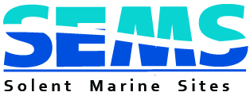

Natural Environment Group (NEG) Project Bidding Pro Forma

Please complete all sections and read the eligibility criteria and timescale at http://www.solentems.org.uk/natural_environment_group/NEG_Projects/.

Project Title:

Project Sponsor/Lead (and full contact details):

Full Address that any Purchase Order should be made out to

Project Description and Objectives:

What is the value of the project to the Solent European Marine Sites (SEMS), other designated sites or areas of conservation interest?

Project Outputs:

Project Timescale and Milestones:

Overall Project Cost (£):
Please detail other funding sources secured/sought.
Funding contribution sought from NEG (£):
The amount requested should be match funded.
Will the project still go ahead without NEG funding?
Geographical coverage of the project:
The project must cover some aspect of the coastal or marine environment of the Solent.
Please list any project partners:
Additional information to support the Bid:

Submission date:

Please email completed forms to solentforum@hants.gov.uk by the last day of February. Important: If you do not get a receipt for your application please phone the office.

